China sends emergency food to drought-stricken provinces
Temperatures and rainfall reach worst levels since 1950s, affecting 18m people and 11m livestock in southern regions.
Jonathan Watts in Beijing and agencies guardian.co.uk, Thursday 25 March 2010
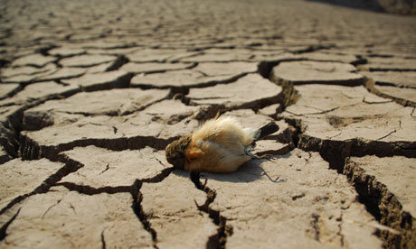
A dead bird lies on the cracked ground as severe drought grips usually water-rich southern China. Photograph: Quirky China News/Rex Features
China has sent 1.4m tonnes of emergency grain supplies to drought-stricken southern provinces that are struggling to cope with the worst drought in decades, the local media reported today.
Authorities say well digging and other relief efforts may also need to be widened as the normally lush and humid region undergoes a dry spell that threatens wildlife, crop production and hydropower generation.
The drought has left 18 million people and 11m livestock in Yunnan, Guangxi, Sichuan and Chongqing without adequate water, according to the ministry of civil affairs.
As Yunnan is home to several of Asia's biggest rivers, including the Yangtze, Mekong and Salween, the downstream impact of a prolonged drought is of concern to almost a billion people.
The economic damage is already estimated at 24bn yuan (about £2.4bn) and with more than 7m hectares of farmland affected, including China's biggest horticulture base, the amount could rapidly grow unless there is rain.
Thousands of water trucks have been sent to the affected area, but in the Himalayan foothills, residents of at least one remote village are having to walk more than 20 kilometres each day to get water.
The authorities have blamed changing weather patterns that have curtailed the rainy season. According to Chen Zhenlin, the spokesman for China's meteorological administration, the average daily temperature in Yunnan over the past six months has been two degrees higher than normal, while the province has had only half the rainfall of an ordinary year. Both are at levels not experienced since the 1950s.
Environmental activists said the government had worsened the problem by encouraging the widespread clearing of forest for rubber and eucalyptus plantations, which are far less capable of conserving water than the original trees. "This has caused significant water and soil erosion and intensified the drought in these regions," said Yu Xiaogang, director of Green Watershed, a local NGO. "We need to review this issue and come up with solutions, otherwise we would face more serious drought problems in the future."
Villagers in Nongtai, a remote corner of Guangxi region, are having to walk six hours a day through the mountains to fetch water for their families, according to the Global Times. Most of them are over 60 years old because all the young and middle-aged adults in the community have left to do migrant work in cities.
With the drought spreading, the government has spent 2.6bn yuan on emergency measures. According to People's Daily, authorities have dispatched tens of thousands of water trucks and strengthened irrigation systems over an area of a million hectares.
The Pearl river delta – the nation's industrial hub – is also being affected. The lake at the source of the Pearl is down to less than a quarter of its normal volume. Hydroelectric dams, which normally generate almost a third of the province's electricity, are underpowered because of low reservoir levels, trimming 10% from supply capacity.

